**BLOOD HELP**

OBJECTIVE

This system that enables management of blood drive operations by connecting people who are interested to donate blood or to receive blood in an emergency situation. To develop a system that automates and makes it easier to search for rare blood types. To develop a system that enables the blood drive coordinator to initiate blood drive All registered members will get the opportunity to share their request through this application. To receive blood, people will be able to search the donor by his location and blood group. After that people will send a request to their nearest persons who have the same bloodgroup. This Application will help to notify important request by SMS and Email notification to the nearest blood donors. Based on request, each donor will have the option to accept or reject the request. Every donor and acceptor have a personal profile.

TECHNOLOGY USED

* **React.js** : Reactjs is a frontend library used to build web applications easily and effectively. We used Reactjs to design the frontend of our application.
* **MongoDb**: MongoDB is a database it is used to store the information related users, donors and requisition in our application we are using mongoDB because it follows noSQL structure to store the data and it is very new than MySQL or SQL database.
* **HTML5**: We used HTML5 to build the structure of our web application.
* **CSS3**: we used CSS for styling the web application.
* **Axios library**: Axios library is used to establish the connection between frontend and backend.
* **Nodjs and Express** : NodeJs and express are used for writing the backend of the application and for writing API, and handling other backend stuff. We are using Nodejs because it is based on the javascript.

METHODOLOGY

Our system will be an interactive website that can be operated by computer, smartphones, tablet etc. Different user will have different user to deal with. In need of urgent blood, sometimes we can’t collect blood or blood donor. For blood donation, one needs to check for a donor or needs to visit blood bank. The Manual Blood donation system has many disadvantages where, it is too time taking process, often leads to error results, consumes lot of manpower, lacks donor information, retrieval of data consumes a lot of time, accuracy is less. At time of emergency, it becomes hard to approach the right donor. Rare blood groups cannot be available all the time at all blood banks and recipients find difficulties to track the right blood donor. Our project with help people in this trouble situation by searching blood donor in the nearest place. Our project will help for getting all information of blood donor. This project is a web based, online blood donation system, named Blood Help. It is a responsive website that allows the people to request for blood and find donors of blood online. There is no role of the admin here. Without registration into the website , user can find out the names of acceptors and donors from their respective list

There are some common features of these application are:

•A. Register as Donor and Requester.

•B. Search Donor

•C. Request Blood

1. SMS/Email Notifications

* **Register as Donor and Requester**

The registration is maintained with a data processing system. Any person can register in this system. The login of register information requires that each user enters the defined usernames and passwords. Email must be unique.

The following data is entered into the register, as applicable:

Name,Email Address,Phone Number,Gender,Blood Group,Location,Aadhar card

When the user lands on the homepage of the website , on the navigation bar it shows the request blood (as acceptor) , on which it will take on the registration of the user to fill their basic details . This will add their name on the requester list where interested people can volunteer it.

* **Search Donor**

The search results are intended for quick searching of multiple entity types. When a people need urgent blood then user search the blood in this application system.When the user lands on the homepage of the website , on the navigation bar it shows the donate blood (as donor) , on which it will take on the registration of the user to fill their basic details . This will add their name on the donor list where interested people are volunteering for it. Every request can be deleted or edited by the user who have their username and password which is stored during their registration process.

* **Request Blood**

This always the probable recipients to make online request to the donor. In urgent situation when need the blood then search donor. There has been filed donors are matched and the request is sent via SMS with necessary details.The user will also get the message of their credentials registered in website . The message will contain their username and password.

* **SMS/Email Notifications**

When the user (acceptor or donor) fills the registration form then SMS/Email is send to the user with their credentials which contains the user’s username and password. When the donor accept the request of the acceptor, the application sends the notification with the information and this notification also displays on the Blood Help website.

RESULT

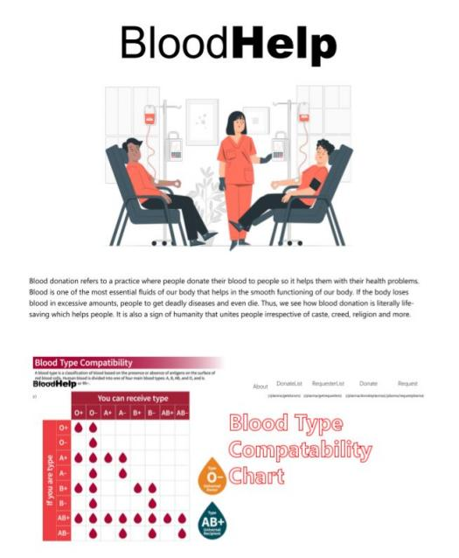

Fig 1. Home Page of Blood Help

The user lands on the home page of the website in which there is the basic description of the `blood donation practice and the blood type compatibility chart through which the donor as well as the acceptor knows which blood type is suitable for which blood.

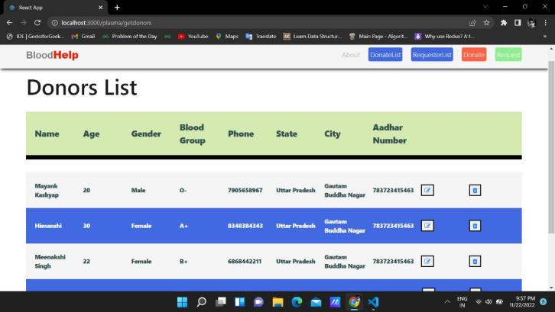

Fig 2. Donor List

When the user clicks on the donate list on the navigation bar then the user will land on the page where there is the list of the donors will appear with their basic details on it.

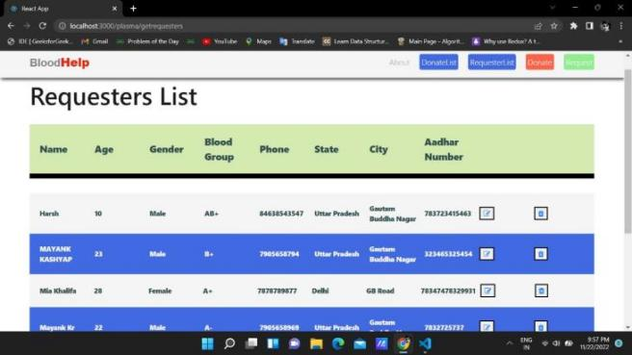

Fig 3. Requester List

When the user clicks on the requester list on the navigation bar then the user will land on the page where there is the list of requesters will appear with their basic details on it.

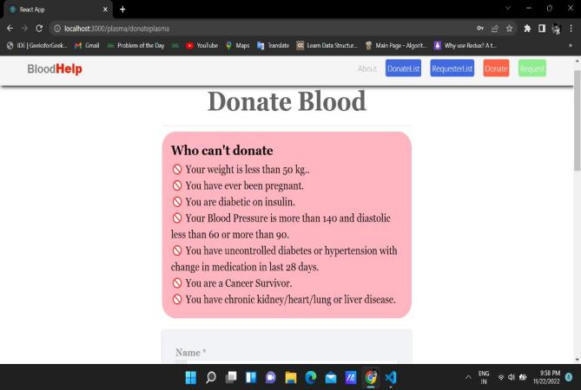

Fig 4. Instructions before donating

When the user wants to donate or request for the blood then user will land on this page in which there is instructions before donating the blood.

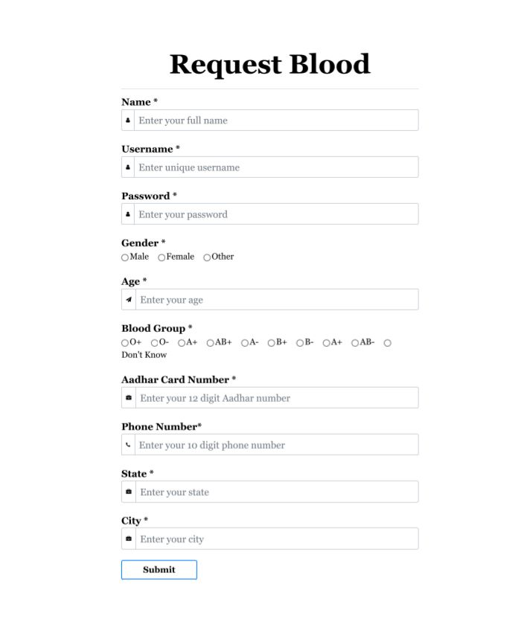

Fig 5. User registration form

After reading out the instruction given above the registration form, user can fill their details and create their account with username and password.